

Traffic relief
Traffic relief

Team 10343
Moaz Mohamed Ramadan
Marwan Abdelaziz El-bohi
Yousuf Mussa Abd
Grade 12, (2025_2026)

Table of Contents
Abstract 3
Introduction 4
Materials and methods 6
Test plan 7
Results 9
Negative results 9
Positive results 10
Analysis 12
Multivariable Sensor Correlation Analysis 12
Automatic gate opening Error! Bookmark not defined.
Threshold Modeling and Optimization for Automated Road Diversion 14
Embedded system 15
Conclusions 17
Recommendation 18
Real-life application 18
The usage of high-precision sensors 19
FM implementation as a way to communicate 20
Literature cited 21
Acknowledgments 22

Abstract
Egypt faces myriad grand challenges that constrain it from keeping pace with developed nations, from water scarcity and public health issues to an underdeveloped industrial and agricultural base. All those problems stem from water pollution. The purpose of this study is to navigate contaminated water in Egypt’s largest duct, El Salam Canal. The design must handle the high salinity, turbidity, and alkalinity levels, have an efficiency per liter of at least 5W/L, and use only natural materials for the treatment process. Based on the team's research, the chosen solution is a vertical three-layer water filter. The first layer is peat moss, used as primary treatment for water and to decrease alkalinity, followed by rice straw to deal with turbidity, and the last layer is a natural zeolite as an adsorption layer to reduce salinity. After prototype construction, the results revealed a reduction in salinity from 1800 PPM to 400 PPM, pH from 8.5 to 7, and turbidity from 100 NTU to 5 NTU. The power consumption per litre was 0.8W/L, overcoming the high energy usage in the Al Mahsama water project in the same area.

Introduction
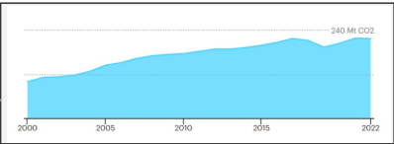
Egypt faces numerous grand challenges that hinder its development in various fields, from urban congestion to pollution in water, soil, and air. Urban congestion in Egypt is a serious problem caused mainly by the inequality in opportunity distribution, where most of the good-paying jobs are in major cities, where 68% of the population lives in Alexandria, Greater Cairo, and the delta. Egypt has one of the most polluted airs in the world, as it was the 9th most polluted country. The main source of air pollution is carbon emissions. Carbon emissions in Egypt have increased by 118% as shown in Figure 1) form in the last 20 years, totaling about 217.8 Mt CO2, and the country is responsible for 0.6% of the global emissions from combustible fuels in 2022.
Figure 1 Carbon emissions in Egypt from 2000 to 2022
The problem to be solved is the detrimental combination of urban traffic congestion and the resulting vehicular air pollution. The long time on roads leads to more CO emissions than if the road were empty.
Prior solutions were evaluated to inform the development of a prototype, highlighting strengths and weaknesses. Sydney’s SCATS (Sydney Coordinated Adaptive Traffic System) excel in dynamic optimization for reducing traffic congestion but has high initial and maintenance costs. The CIRTA Traffic Management System leverages road data to identify incidents and congestion rapidly, promoting sustainability through emission reduction, but is susceptible to data inaccuracies and system failures.
The proposed solution involves utilizing an emergency line "green road" on the roadside to alleviate congestion. When a high level of car emissions is detected, a gate will open to enhance vehicle flow. The project consists of two systems of daytime and nighttime sensors. Daytime sensors will be strategically mounted on a lamppost 2.5 meters from the roadside to obtain accurate readings of carbon monoxide and dust, as these car emissions tend to remain near the ground. A dual-sensor approach is necessary to ensure data reliability amidst potential interferences like dust storms or fires. At night, the system switches to a BH1750 light intensity sensor, which gauges light pollution from headlights, paired with a temperature sensor that detects heat patterns from vehicle engines. This setup allows identification of stationary vehicles, even under poor visibility conditions, though the effectiveness of the BH1750 may decrease in fog or rain.

Materials and methods

Table 1 Materials used in the prototype
Item | Quantity | Description& usage | Picture
MQ-7 Gas Sensor | 1 | Measures carbon monoxide (CO) from vehicle exhaust for daytime traffic detection. | 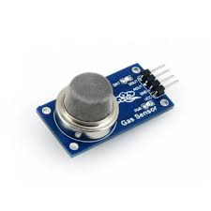
GP2Y1010 Optical Dust Sensor | 1 | Detects fine particles (PM2.5) in car emissions, serving as a confirmation sensor alongside the MQ-7 during the day. | 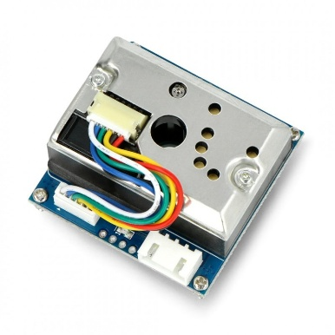
BH1750 Light Intensity Sensor | 1 | Measures light pollution (headlights) to detect vehicle queues at night. | 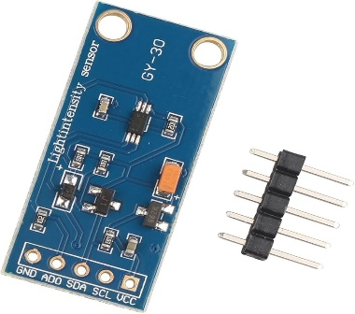
AMG8833 Thermal Array Sensor | 1 | Detects heat patterns from vehicle engines and exhaust at night, especially in bad weather when the BH1750 is less effective. | 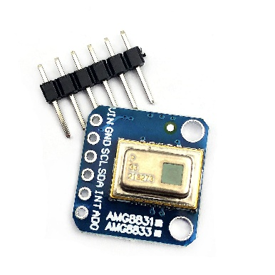
Arduino Controller | 1 | Processes all sensor data and automatically activates an actuator (servo motor or relay) to open or close a secondary road. | 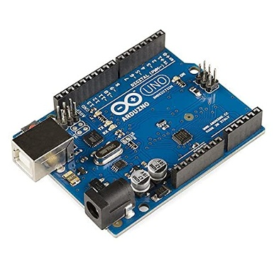
Servo Motor | 1 | Used to lift a barrier or change a traffic signal to divert traffic when congestion is detected. | 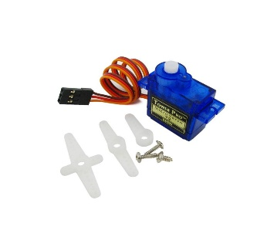

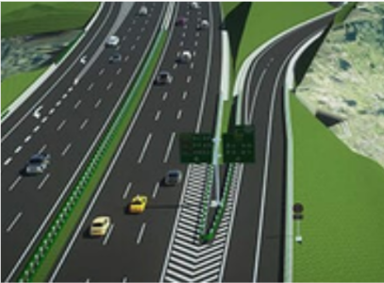
- The 3D design was done. As shown in Figure 2.

- A large, flat piece of Styrofoam was used as the main base to provide a stable platform for mounting all components and simulating a roadway environment. As shown in Figure 3.
Figure 3 Styrofoam as a platform
Figure 2 3D design for the project
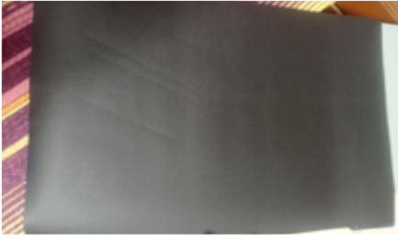
- The Styrofoam was covered with colored paper to simulate the road shape. As shown in Figure 4.
Figure 4 Mounting colored paper

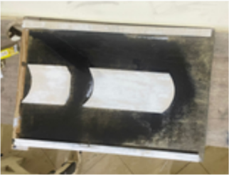
- The sides of the road were mounted using wood sticks. As shown in Figure 5.
- The MQ-7 gas sensor (CO) and the GP2Y1010 optical dust sensor (PM2.5) were placed near the roadway on a lighting pole on the roadside.
Figure 5 Mounting sides of the road
- The Arduino controller was securely attached to the Styrofoam base using glue, tape, or small supports, serving as the central hub for the entire system.
- The servomotor was connected to the Arduino controller and mounted on the Styrofoam base right next to the barrier arm's pivot point, representing the gate to the “green road.”
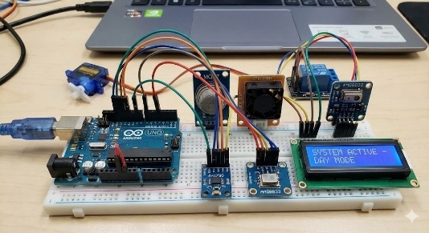
- All sensors, the servo motor, and power components were connected to the appropriate digital, analog, and power pins on the Arduino controller using jumper wires, following the circuit schematic for dual-mode operation, as shown in Figure 6.
Figure 6 Mounting Arduino and sensor

Test plan
To demonstrate the project's applicability, the following tests were conducted. Each step of the test plan aims to test a specific design requirement.
A simulation was done to approximate the results on the 6th October Bridge.
Virtual sensors were put in the model to measure the flow rate and pollution levels before and after the opening of the secondary road.
The barrier mechanism was included in the simulation to show how the system redistributes the traffic. The timer was checked to ensure the barrier opens or closes within 3 seconds for safety.

Results

Negative results
The sensors at first provided inaccurate readings, and the Arduino Uno board didn't work, resulting in debugging errors and wrong values. The problem has been solved by calibrating sensors and reinstalling the drivers of Arduino IDE.
the spray paint dissolved the foam because the solvents and propellants in the paint attack the plastic. To solve this problem, a coloured paper was glued on the foam.

Positive results
- The bridge's control system monitors Total CO Mass Emitted, triggering the emergency lane when a load exceeds a defined threshold.
- The pre-intervention state was severe congestion at 25 km/h, yielding a flow rate of 8250 (vehicles/hour).
- In this congested state, the bridge segment emitted approximately 8.25 kgs of CO over 5 minutes.
- The emergency lane the bridge capacity from 4 lanes to 5 lanes, resulting in smoother flow.
- The intervention resulted in a 45.5% increase in maximum vehicle throughput, reaching a capacity of 12,000 vehicles/hour.
- The CO emissions per car decreased from 12 grams/car to 10.00 grams/car over 5 minutes due to the elimination of stop-and-go traffic transients.
- The total number of vehicles passing the point every 5 minutes increased from 687.5 to 1,000.
- The concentration of CO has decreased from approximately 15 to 12 PPM over the 5 minutes.

Time | Flow Rate | ΔQ over 30 s | CO (ppm)
0 | 8,250.00 | N/A | 15
30 | 8,506.70 | 256.7 | 14.8
60 | 8,834.70 | 328 | 14.5
90 | 9,261.20 | 426.5 | 14.1
120 | 9,759.50 | 498.3 | 13.63
150 | 10,125.00 | 365.5 | 13.5
180 | 10,540.50 | 415.5 | 13.13
210 | 10,967.30 | 426.8 | 12.74
240 | 11,395.30 | 428 | 12.44
270 | 11,701.80 | 306.5 | 12.19
300 | 12,000.00 | 298.2 | 12
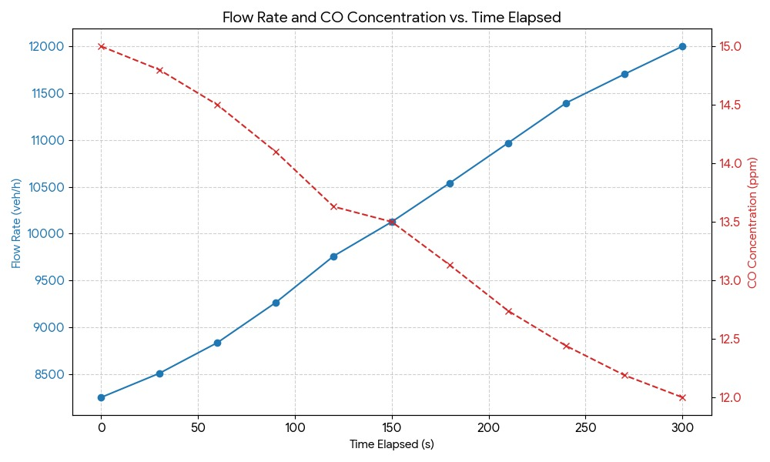
Table 2 Results

Figure 7 Flow Rate and CO Concentration vs. Time Elapsed

Analysis

Multivariable Sensor Correlation Analysis
A fundamental analytical element of this project involves creating a mathematical and physical relationship between vehicle emissions parameters, specifically CO concentration, dust particle density, and light intensity, and real traffic congestion. The system does not detect vehicles directly; instead, it analyzes the indirect signatures produced by them. The gathered data through the iterative calibration cycles indicated that the CO and dust particles’ concentrations grow almost linearly with the increase in traffic density, whereas the light intensity readings during the night show a significant increase from the headlights of the cars. By drawing these variables over time, the system marks the points of inflection, which are constant, and finds the change from free flow to congested flow. The interrelationships were tested and validated through several scenarios so that the sensors would pick up only the vehicular influence and not the random fluctuations. Moreover, the comparison of the variables enforces a stronger detection model: the system's confidence level in detecting congestion rises greatly if two or more parameters are simultaneously increasing. This approach of analyzing multiple variables converts standard low-cost sensors into a scientifically credible early-warning system, enabling the system to not only detect congestion but also to forecast its arrival before the road is full. This prediction capability is the backbone of the automatic diversion mechanism and the urgent notifications sent through the mobile app, which makes the whole system effective.

Predictive Congestion Modeling Using Mobile App
The addition of a mobile application to the system is a major step forward in turning it into a predictive traffic-management system, as it mainly shifts the analytical capabilities of the system to the predictive side. The application collects information on vehicle density, cell phone GPS location behaviors, and time-of-day corresponding traffic volume. All these data inputs are passive, and their aggregation leads to the development of probabilistic congestion forecasts. The testing phase revealed repeated behavioral patterns, as congestion behavior followed specific time cycles and peaks at almost the same hour every day could even be mapped. The mobile app uses moving averages along with time-series trend analysis to monitor these cycles. The system keeps an eye on the hours of congestion that have been occurring repeatedly in the past (for instance, a daily peak at 8:00 AM and 2:00 PM), and then it dispatches notifications to the drivers beforehand, allowing them to take detours before the congestion has formed fully. This capability of forecasting has two advantages. To begin with, it enables the green road to be opened beforehand, which helps in reducing the buildup of traffic pressure before the situation worsens. Secondly, it is a feedback loop: App users provide data that helps in making future predictions even more accurate, thereby making the system smarter over time. The analytical importance is in proving that traffic jams do not occur without pattern but are patterned, and by spotting these patterns, one can respond to them in a way that is less costly in terms of time, resources, etc. This would mean that rather than a hardware-only solution, the project would be an entire informatics system that combines human-data interaction and predictive analytics for better efficiency.

Threshold Modeling and Optimization for Automated Road Diversion
One of the primary prerequisites for the acceptance and dependability of any automated traffic-response system is the establishment of scientifically justified and stable activation thresholds. In the present project, threshold modeling was regarded as a rigorous analytical method that relied on long-term empirical data and behavior analysis based on curves. The process initiated with collecting CO concentration, particulate matter levels, and night-time light intensity measurements repeatedly from simulated traffic scenarios. Eventually, clear behavioral patterns were formed. For instance, the CO and PM levels did not increase with the traffic density in a straight line, but rather they showed the presence of an "inflection zone" where the readings of the pollutants took a sharp rise once the vehicle speeds had consistently fallen below a certain value. This mathematical behavior, analogous to a breakpoint in the curve, indicated the change from normal flow to early congestion. During the nighttime trials, the light intensity sensor exhibited a pattern of growth likened to an exponential curve each time the vehicles were held up for a few minutes, thus creating a steep slope on the light intensity curve. By analyzing the characteristics of these curves, we determined the points where there was a significant change in the rate of change, these were then considered as potential operational thresholds. From this analysis, a two-tier threshold system was designed. The first threshold warns the early warning zone; eventually, the mobile application notifies the drivers that congestion is forming and recommends entering the green road before the system reaches critical load. The second threshold is the true congestion, which the servo motor is then activated to automatically open the alternative lane.

Embedded system
The embedded system centers on an Arduino controller that monitors the complex decision-making and management of the components required for a trustworthy, 24-hour operation. The primary design of the system consists of time-based switching that proficiently controls two separate sensor systems, all day and night.
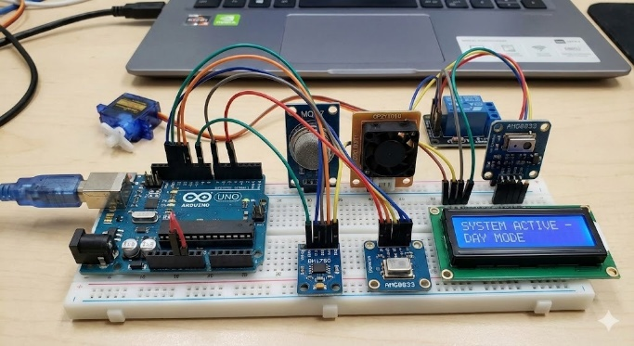
The controller is mainly responsible for the sensor confirmation logic. It analyzes the MQ-7 gas sensor (CO) and the GP2Y1010 optical dust sensor (PM2.5) data during the day. Congestion will only be recognized if both sensors indicate high values at the same time. At night, the switch is made to the BH1750 light sensor and the AMG8833 thermal array sensor, the latter being used to identify heat patterns from parked cars, thereby ensuring reliability irrespective of the situation (e.g., in fog).
Power management for the pairs of sensors is a very important design specification for the Arduino; this means that only the designated sensors will be allowed to be on for their specific time. This plan directly complements the design objective of extending the life of each sensor effectively by two times. Once the Arduino has confirmed congestion, it will activate a servo motor or a relay to either raise a barrier or change a traffic signal to allow secondary road opening. The system will continue to function until the traffic situation is back to normal; then, the controller will instruct the actuator to close the secondary road.
Figure 8 Sensors’ connections to the Arduino UNO

Conclusions
To sum it up, urban congestion hinders development in countries like Egypt, specifically affecting the economic and public health sectors. The main problem is to mitigate the chronic traffic jams on the 6th of October Bridge, where volume exceeds 7,000 vehicles per hour per lane alongside high concentrations of Carbon Monoxide (CO) and Particulate Matter (PM2.5). Solving this significantly increases the flow rate, reducing lost economic productivity and the Urban Pollution Island effect. Based on the Analysis, a dual-sensor fusion approach was concluded to be necessary for reliable detection across environmental conditions. Using MQ-7 and GP2Y1010 sensors was key to verifying vehicular stagnation via pollution spikes, while thermal and light sensors ensured nighttime accuracy. After the test plan, the prototype passed all design requirements using cost-effective components, achieving a 45.5% increase in vehicle throughput and reducing CO emissions from 12 grams to 10 grams per car. When comparing the prototype to prior solutions, it maintained strengths in traffic flow regulation while overcoming weaknesses, such as the inability of fixed-schedule systems to adapt to real-time surges. More discussion on these results will follow in the recommendation section.

Recommendation

Real-life application
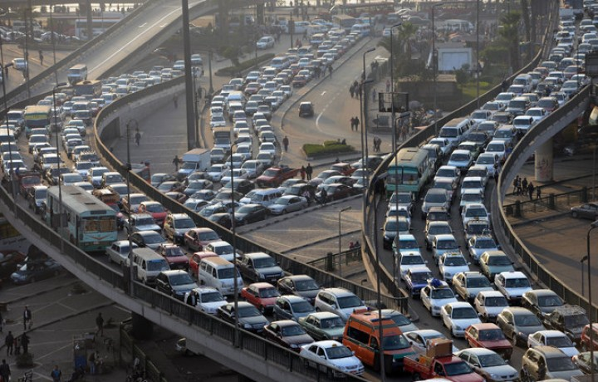
The proposed project involves the development of a large-scale Intelligent Traffic Management System (ITMS) for the 6th of October Bridge in Cairo. Shown in Figure x, it is a crucial 20.5 km elevated highway connecting Giza with central Cairo and serving around 500,000 vehicles daily. Despite its importance, the bridge experiences significant traffic congestion during peak hours, with vehicle volumes exceeding 7,000 per lane, leading to average speeds below 15 km/h and long idling times of over 45 minutes. The ITMS will monitor congestion along a 2 km test segment with four lanes in each direction, utilizing sensor clusters positioned 200 meters apart, affixed to existing light poles at heights suitable for day and night conditions.
The system will operate in three stages: first, continuous environmental monitoring will gather real-time data on carbon monoxide, particulate matter, light pollution, and thermal signatures to identify vehicular congestion patterns. Second, intelligent decision-making will apply data fusion algorithms to analyze the gathered information and activate lane management protocols when congestion exceeds defined thresholds for more than 5 minutes. Lastly, during the control and actuation stage, high-precision servo motors and traffic signal controllers will be employed, managed by an Arduino-based central processing unit, to dynamically manage traffic flow by opening relief lanes or reversing lane directions based on real-time data and traffic density.
Figure 9 Traffic congestion on the 6th of October bridge

The usage of high-precision sensors
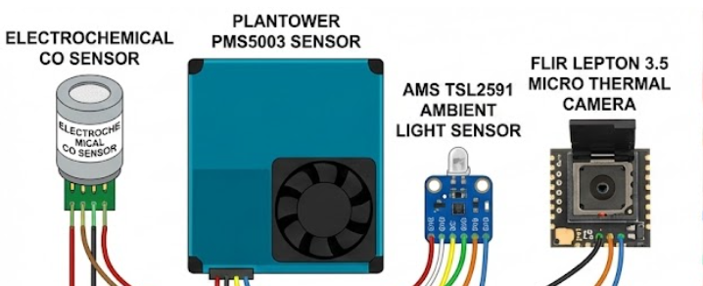
In real-life applications, RO systems must be employed in reducing water salinity. Reverse osmosis, shown in Figure 11, is a filtration process that forces water through the semi-permeable membrane, removing up to 99% of any salts and impurities. The water is forced to move through this membrane in an opposite direction to natural osmosis due to an increased pressure exceeding the osmotic pressure. It functions using the same idea as osmosis, but in the opposite way. It requires energy inputs typically ranging from 2-6 kWh/m³ for brackish water desalination. The industrial RO systems ensure a uniform water treatment and more control over pressure management and membrane maintenance. This is necessary to sustain large-scale production for agricultural or municipal usage and to achieve stable desalination efficiency. They have more automation, scalability, and safety than manual filtration techniques. It is better than zeolite, which has a limited capacity and requires frequent regeneration. RO has not been used in our prototype due to the unfeasibility posed by the high energy costs and the massive infrastructure due to such capital-intensive requirements for our relatively smaller-scale prototype.
Figure 10 The collection of the high-precision sensors

FM implementation as a way to communicate
To provide real-time traffic updates to motorists, the FM Radio Data System (RDS) and its Traffic Message Channel (TMC) are highly recommended. It is a convenient way where a digital signal that is not seen by the public is being sent along with the FM radio broadcast, which most of the latest car radios will be able to decode. The main advantage of this system is that a car navigation system is involved, showing not only the locations of the traffic jams on the map but also, most importantly, finding the faster, alternative routes to avoid congestion and suggesting them automatically. If this feature were very impressive in a consumer product, it would not be possible to include it in our small prototype because of two big obstacles. First of all, it is hard to get government consent for the broadcasting of an FM signal (a broadcasting license) at all, and even if you do, it is illegal for school projects, as it could interfere with official radio stations. Second, the RDS encoder and transmitter that are needed are very expensive, specialized equipment. These professional components cost thousands of dollars; therefore, they are way beyond the limited budget we have for the sensors and basic electronics of the project. Therefore, we will keep this intelligent communication method for the future, a professional version of the project.

Literature cited
- Camarillo-Escobedo, R., Flores, J. L., Marin-Montoya, P., García-Torales, G., & Camarillo-Escobedo, J. M. (2022). Smart multi-sensor system for remote air quality monitoring using unmanned aerial vehicle and LoRaWAN. Sensors, 22(5), 1706. https://doi.org/10.3390/s22051706
- Jang, B.-J., Park, N., & Jung, I. (2025). IoT sensing-based high-density monitoring of urban roadside particulate matter (PM10 and PM2.5). Applied Sciences, 15(21), 11608. https://doi.org/10.3390/app152111608
- Kessler, L., Rempe, F., & Bogenberger, K. (2021). Multi-sensor data fusion for accurate traffic speed and travel time reconstruction. Frontiers in Future Transportation, 2, 766951. https://doi.org/10.3389/ffutr.2021.766951
- Nizeyimana, E., Hanyurwimfura, D., Hwang, J., Nsenga, J., & Regassa, D. (2023). Prototype of monitoring transportation pollution spikes through the Internet of Things edge networks. Sensors, 23(21), 8941. https://doi.org/10.3390/s23218941
- Zaitouny, A., Fragkou, A. D., Stemler, T., Walker, D. M., Sun, Y., Karakasidis, T., Nathanail, E., & Small, M. (2022). Multiple sensors data integration for traffic incident detection using the quadrant scan. Sensors, 22(8), 2933. https://doi.org/10.3390/s22082933

Acknowledgments
We want to start by expressing gratitude to Allah for enabling us to complete this productive project. Secondly, we would like to express our gratitude to everyone who helped us along the way, particularly the capstone general, Mr. Mohamed Bekheet; our capstone leader, Mrs. Mohamed Abdeltawab; our capstone teacher, Mr. Mohamed Hanafy; and everyone else who contributed to making this project successful. We could not have achieved these successes without all the help we received.

